Insurance company
Database creation:
create database insurance;
use insurance;
Data exploration:
Checking the data are correctly entered/not:
select * from insurancedata limit 10;
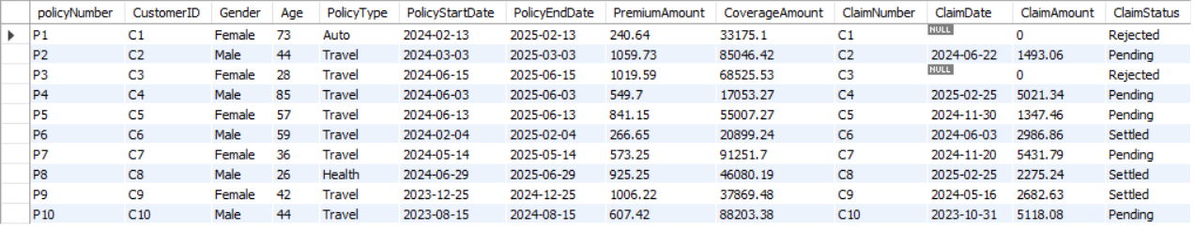
Checking no of data entered are correct or not
select count(*) from insurancedata;
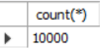
Data cleaning:
changing the column name which is wrong
alter table insurancedata
rename column ï»¿PolicyNumber to policyNumber;
Checking duplicates
select policyNumber, count (*) from insurancedata group by policyNumber having count (*)>1;
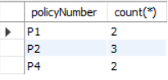
Remove duplicate records
CREATE TABLE newinsurance (LIKE insurancedata);
INSERT INTO newinsurance SELECT DISTINCT * FROM insurancedata;
drop table insurancedata;
rename table newinsurance to insurancedata;
select policyNumber, count(*) from insurancedata group by policyNumber having count (*)>1;

Checking wrong values :
- select distinct policyNumber from insurancedata;
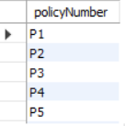
- select distinct customerid from insurancedata;
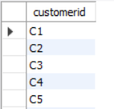
- select gender from insurancedata where gender not in ("Male","Female");

- Blank means absence of wrong values.
- select distinct policytype from insurancedata;

- select distinct policystartdate from insurancedata;
- select distinct policyenddate from insurancedata;
- select premiumamount from insurancedata where premiumamount <0;
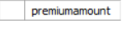
- select coverageamount from insurancedata where coverageamount <0;
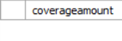
- select distinct claimdate from insurancedata;
- select claimamount from insurancedata where claimamount <0;

- select distinct claimstatus from insurancedata;
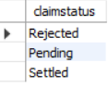
- select age from insurancedata where age < 0 or age >100;
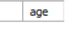
Checking null values :
select sum(case when policynumber is null then 1 else 0 end)as policynumber_null,
sum(case when customerid is null then 1 else 0 end)as customerid_null,
sum(case when gender is null then 1 else 0 end)as gender_null,
sum(case when age is null then 1 else 0 end)as age_null,
sum(case when policytype is null then 1 else 0 end)as policytype_null,
sum(case when policystartdate is null then 1 else 0 end)as policystartdate_null,
sum(case when policyenddate is null then 1 else 0 end)as policyenddate_null,
sum(case when premiumamount is null then 1 else 0 end)as premiumamount_null,
sum(case when coverageamount is null then 1 else 0 end)as coverageamount_null,
sum(case when claimnumber is null then 1 else 0 end)as claimnumber_null,
sum(case when claimdate is null then 1 else 0 end)as claimdate_null,
sum(case when claimamount is null then 1 else 0 end)as claimamount_null,
sum(case when claimstatus is null then 1 else 0 end)as claimstatus_null
from insurancedata;
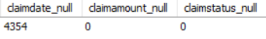
Data Transformation :
Changing data types
alter table insurancedata
modify policystartdate date,
modify policyenddate date,
modify claimdate date;
Adding new column profit_or_loss:
alter table insurancedata
add profit double;
update insurancedata
set profit_or_loss=premiumamount-claimamount
select profit from insurancedata limit 5;
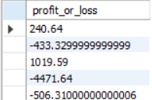
Adding new column age group
alter table insurancedata
add AgeGroup varchar(15);
update insurancedata
set AgeGroup = case when age between 18 and 34 then "Young Adult"
when age between 35 and 59 then "Middle_aged"
else "senior citizen"
end;
select age, ageGroup from insurancedata limit 5;
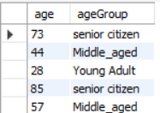
Each customer has single claim and customerid are identical with claim number
select customerid,count(claimnumber) from insurancedata group by customerid ;
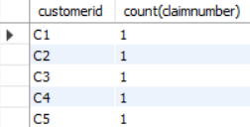
select count(*) from insurancedata where customerid=claimnumber;
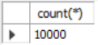
Changing the values of claim number to make differ from customer id
update insurancedata
set claimnumber = concat('CN', substring(claimnumber, 2))
where claimnumber like 'C%';
select claimnumber from insurancedata limit 5;
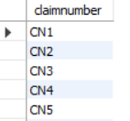
Data Analysis:
KPI’S Analysis-
Total no of policies:
select count(distinct policynumber) as total_policies from insurancedata;

Total no of customers :
select count(distinct customerid) as total_customers from insurancedata;

Total premium amount:
select cast(sum(premiumamount)as decimal(10,2)) as total_premiumamt from insurancedata;
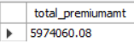
Average premium amount per policy number:
select round(avg(premiumamount),2)as avg_premium from insurancedata;
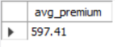

Total coverage amount:
select round(sum(coverageamount),2)as total_coverageamt from insurancedata;

Total claim amount:
select round(sum(claimamount),2)as total_claimamt from insurancedata;
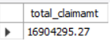
Total profit/loss:
select round(sum(profit_or_loss),2) as overall_profit_or_loss from insurancedata;
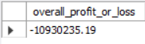
Client’s questions –
Policy type wise no of claims:
select policytype,count(claimnumber)as no_of_claims from insurancedata where claimnumber!="No claim" group by policytype order by no_of_claims desc;
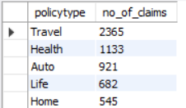
- Travel policy has max no of claims
- Home policy has min no of claims
Percentage of policies type based on claim vs no claim:
select policyType, case when claimamount > 0 then "claimed" else "Not claimed" end as claim_status,count(*) as total_policies,
round(count(*)* 100.0 / sum(count(*)) over (partition by policytype),2)as percentage from insurancedata group by policytype,claim_status order by policytype,claim_status;
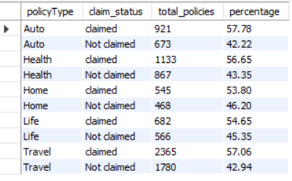

Policy type wise highest avg claim amount:
select policytype,round(avg(claimamount),2)as avg_claimamt from insurancedata group by policytype order by avg_claimamt desc;
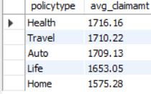
- Policy type has highest avg claim amount is health
- Policy type has lowest avg claim amount is home
Customer or age group wise high risk:
select customerid,agegroup,sum(claimamount),sum(premiumamount),round(sum(claimamount) / sum(premiumamount), 2) as claim_ratio,
case
when count(claimnumber) > 2
or (sum(claimamount) / sum(premiumamount)) > 0.8
then 'high risk'
when (sum(claimamount) / sum(premiumamount)) between 0.5 and 0.8
then 'medium risk'
else 'low risk'end as risk_category,count(claimnumber) from insurancedata where claimnumber !="no claim" group by agegroup,customerid limit 10;
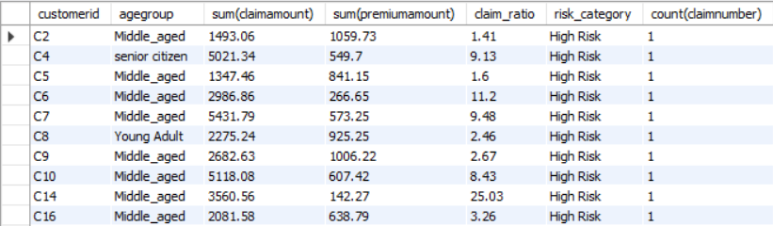
- Here every customer has single claim but claim ratio (customer having claim amount> premium amount paid) >80%.Hence high risk to the insurance company and can cause future loss.
Age group wise claim & policies:
select agegroup,sum(premiumamount),count(claimnumber) from insurancedata where claimamount=0 group by age group;
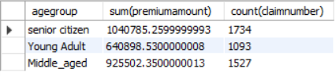
select agegroup,sum(claimamount),sum(premiumamount),count(claimnumber) from insurancedata where claimamount>0 group by agegroup;
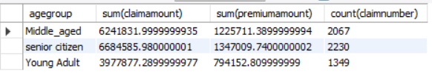
- Max claim amount by senior citizen
select agegroup,count(policynumber) from insurancedata group by agegroup;
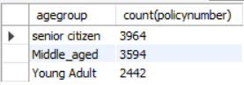
Age & gender group wise profit:
select
agegroup,sum(premiumamount) as total_premium,
sum(coalesce(claimamount, 0)) as total_claim_amount,
round(sum(premiumamount) - sum(coalesce(claimamount, 0),2) as total_profit
from insurancedata group by agegroup;
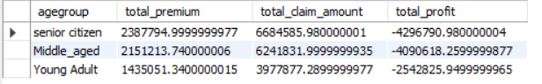
select
agegroup,gender,sum(premiumamount) as total_premium,
sum(coalesce(claimamount, 0)) as total_claim_amount,
round(sum(premiumamount) - sum(coalesce(claimamount, 0)),2) as total_profit
from insurancedata group by agegroup,gender order by total_profit asc limit 1;
Loss making policy:
select
policytype,sum(premiumamount) as total_premium,
sum(coalesce(claimamount, 0)) as total_claim_amount,
round(sum(premiumamount) - sum(coalesce(claimamount, 0)),2) as total_profit
from insurancedata group by policytype order by total_profit asc limit 1;
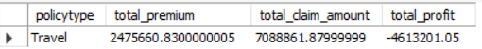
- Among all age groups, senior citizens male generate the highest loss because their total claim payouts significantly exceed the premiums collected.
- To reduce loss, we should increase premiums and , controlling coverage limits and introducing deductibles to manage claim payouts and reduce loss.
- A deductible is the amount the customer must pay from their own pocket before the insurance company pays anything to reduce loss.
- Travel policy is the max loss -making policy.

